**运行代码**

#include <iostream>

using namespace std;

static float m_classMoney = 1000;

class TStudent

{

char* name;

public:

void InitStudent(char name[])

{

name = name;

}

void ExpendMoney(float money, char name[]);

void showMoney();

};

void TStudent::ExpendMoney(float money, char name[])

{

m_classMoney -= money;

cout << name << "花费班费" << money << "元" << endl;

}

void TStudent::showMoney()

{

cout << "班费还剩余" << m_classMoney <<"\n" << endl;

}

int main()

{

TStudent stu[3];

char name[3][100];

int i;

double money[3] = { 50,98.5,500.53 };

for (i = 0; i < 3; i++)

{

cout << "请输入姓名:";

cin >> name[i];

stu[i].InitStudent(name[i]);

stu[i].ExpendMoney(money[i],name[i]);

stu[i].showMoney();

}

**运行结果**

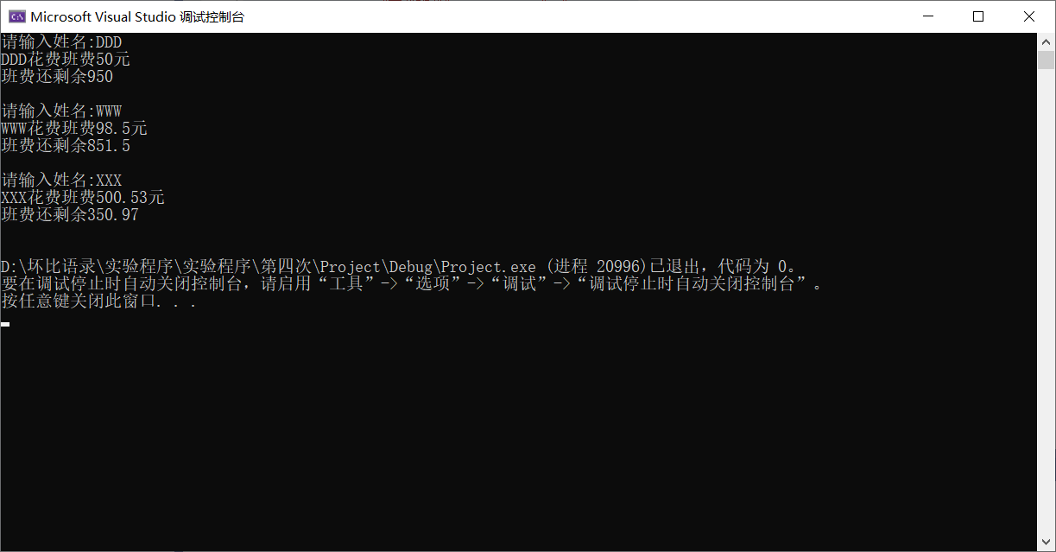

**感想和心得**

**了解派生类和继承，本次上机实验的目的是掌握派生类的声明方法和派生类构造函数的定义方法、掌握不同方式下，基类成员在派生类中的访问属性。**

**程序越来越复杂，语言也多了起来。难度增加。**